Formatting Integers
We can also use format() function to format integers. Type codes d, b, o, x can be used to format in decimal, binary, octal and hexadecimal respectively. Remember that while formatting integers only width is allowed not precision.
1  2  3  4 | >>>  >>> print(format(95, "5d"))  95  >>>
Try it now
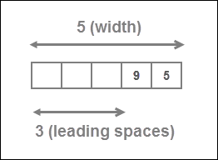
1  2  3  4 | >>>  >>> print(format(4, "b")) # prints the binary equivalent of decimal 4  100  >>>

1  2  3  4 | >>>  >>> print(format(255, "x")) # prints the hexadecimal equivalent of decimal 255  ff  >>>

1  2  3  4 | >>>  >>> print(format(9, "o")) # prints the octal equivalent of decimal 9  11  >>>

1  2  3  4 | >>>  >>> print(format(100, "<10d")) # Left align the number within specified width  100  >>>
